**Welcome To Asset Management System**

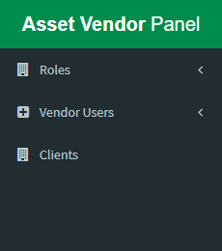**Options / Menu Lists:** There are different types of menu in asset management vendor admin panel. These are:

1. Roles
2. Vendor Users
3. Clients

**Lets we discuss about above option step by step….**

**1. Roles: Role is responsible for user access and permission to a specific user of any vendor.**

In the menu lists the first option is **Roles**. By default when a vendor is enrolled our package he/she get an **admin** role. This is not editable or delete.

* By the way vendor can create / edit / delete his own role except admin role.
* 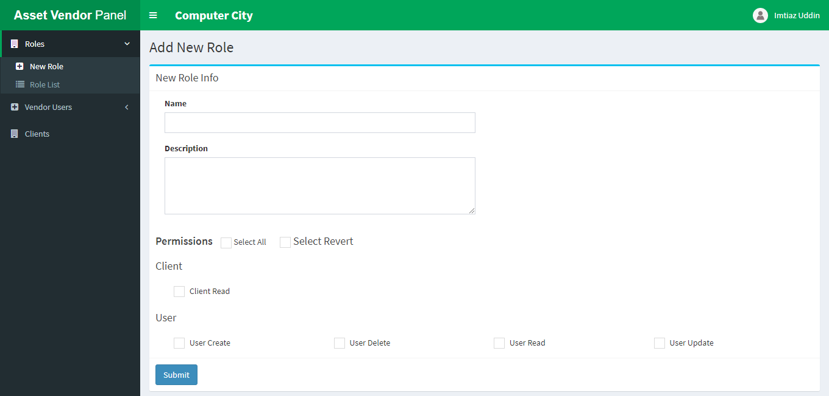To create a role go to Roles => New Role then create your own new role
* From this option you should input name, description and checked permissions which you want to include into this role. Then submit
* 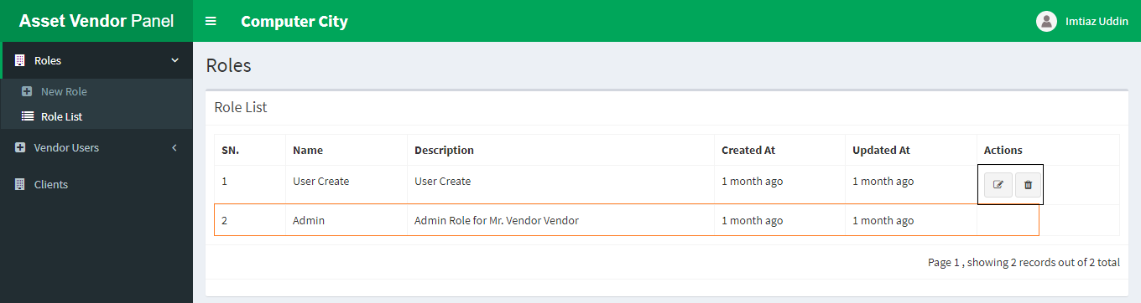After successfully created a role you can see your newly created role from the Role List dropdown menu under Roles.
* From the above list you can see that you have only permission to edit or delete first one but you can’t delete second one.

**2. Vendor users: Vendor Users menu is responsible for creating multiple vendor users which required.**

* 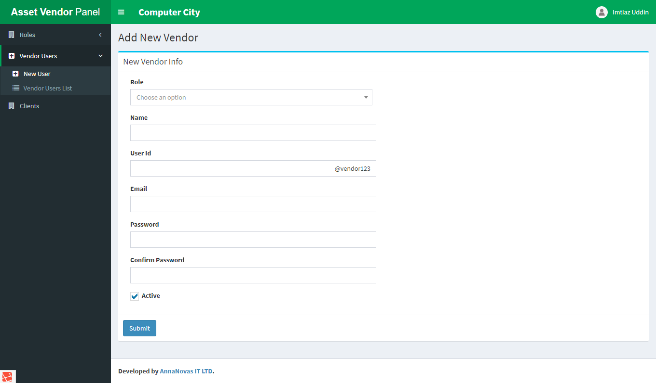To create a new vendor user please navigate to Vendor Users => New User
* 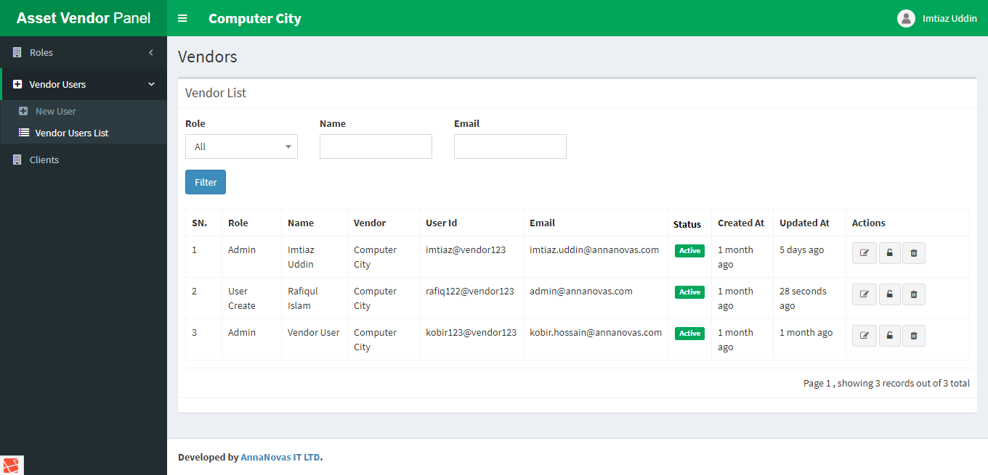After successfully created a user you can see your newly created user from the Vendor Users List dropdown menu under Vendor Users.
* From the Vendor Users List you can edit or delete your user. You can also reset password by clicking lock icon.

**3. Clients: Clients menu is responsible for viewing the clients who are already enlisted you.**

* 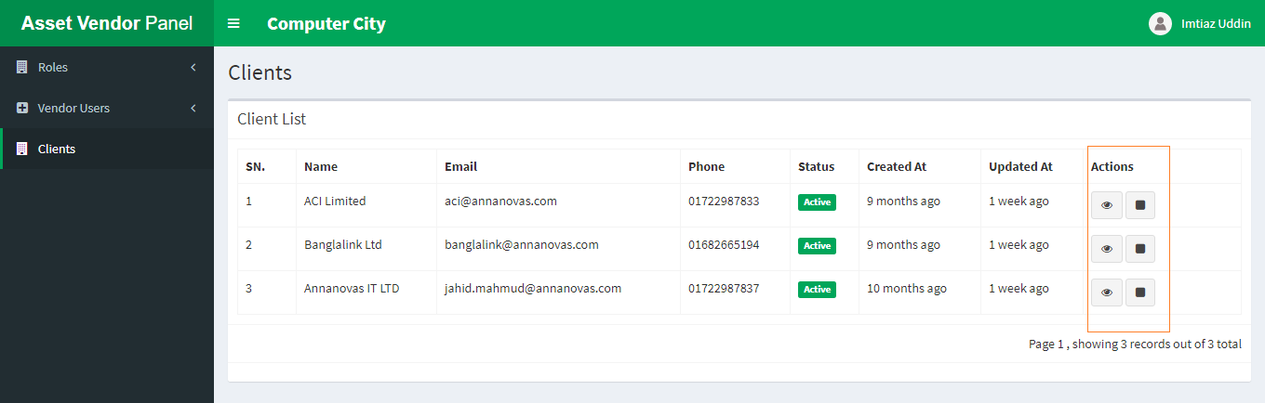By clicking this menu you can see all client lists that are enlist you.
* From above list there are action column which contains two different icons.
* 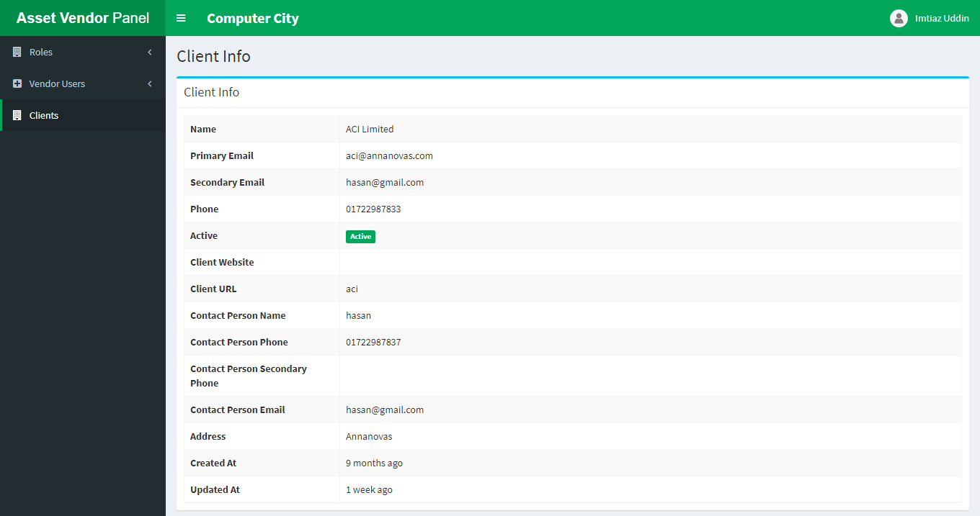1st (eye) icon is responsible for viewing the details of the specific client.
* 2nd (square) icon is responsible for creating or viewing assessment list.
* To create an assessment click this 2nd icon
* From here you can create new assessment. For this at first select which asset you need to be repair and input other input field like required days costing you demand and note. Then submit.
* 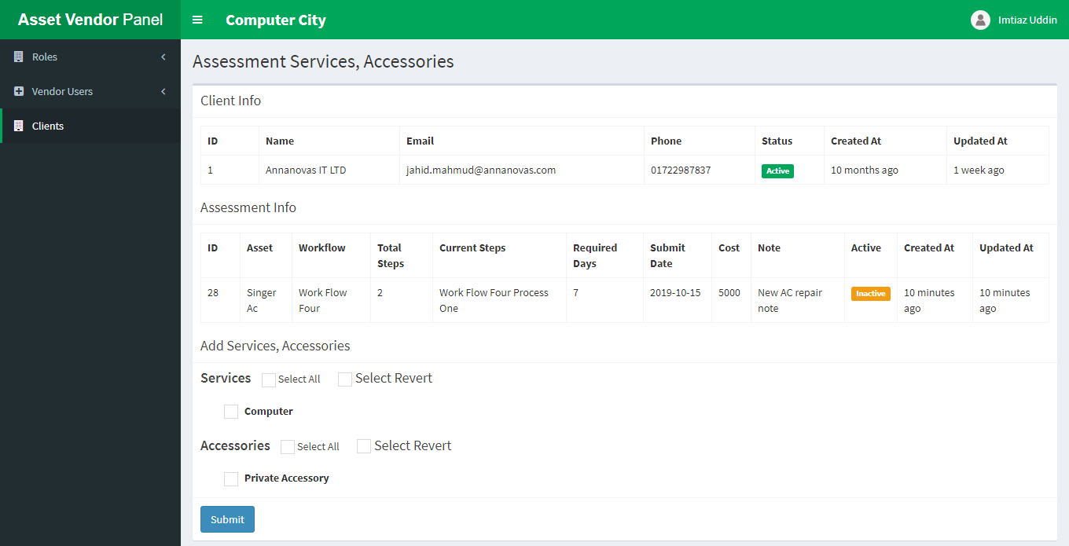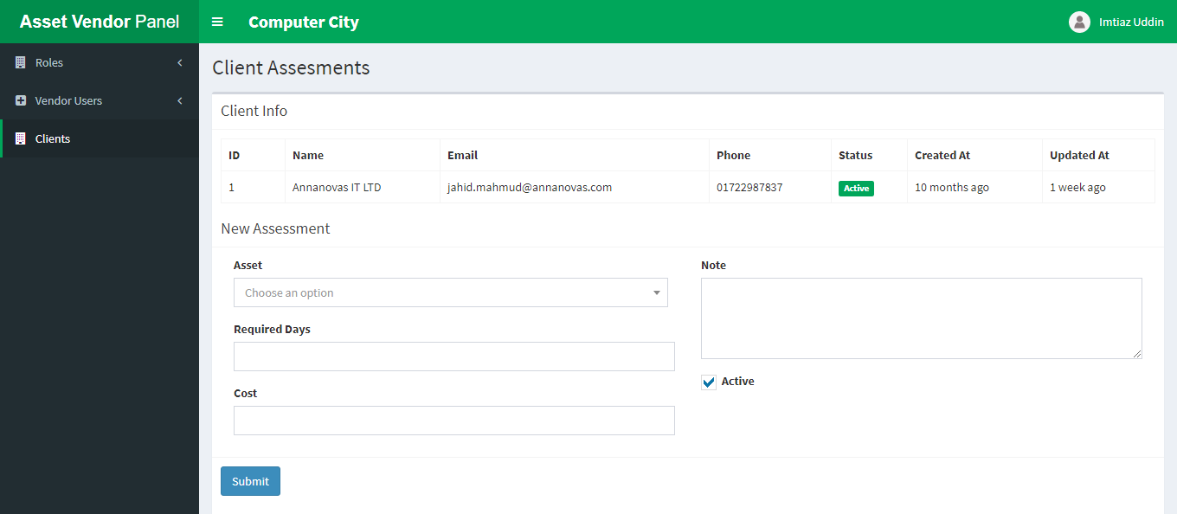When you submit this form then the next assessment services page is appear
* You must have selected either a service or an accessory otherwise process can’t start.
* After successfully submitting this form notification will send to all of client user associate with that asset workflow via email. Also client user can see new pending assessment list into their client panel.
* Vendor user can see their newly created assessment from the list.
* 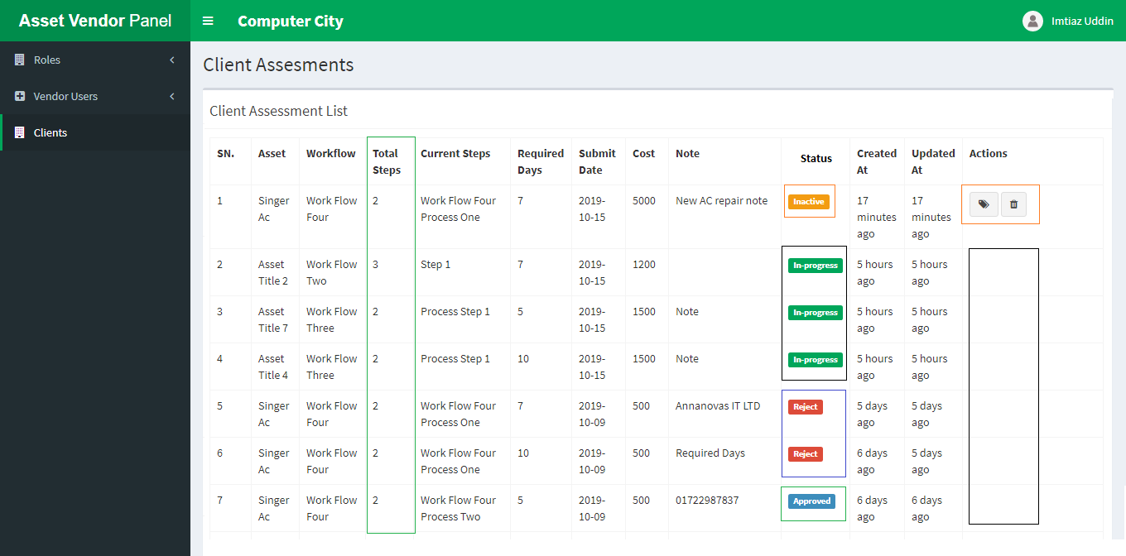From the above list you can see there is lots of option here. Like how many process step associate with specific asset, status etcetera.
* If you not select asset service then your assessment is inactive and you can edit or delete it.
* But if you completed your all step then you can’t edit/ delete any assessment.
* From the above list you can see which assessment is approved and which is rejected.
* If your assessment is in-progress then you can see which process step currently running.